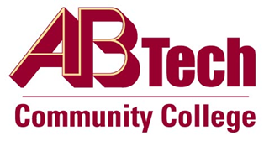

# Asheville-Buncombe Technical Community College (A-B Tech) Policy Manual

## Policy 405: Donations to the College

It is the policy of the Board of Trustees to accept gift offers of supplies, equipment, furniture, books, collectibles, vehicles, real estate, cash, stocks, life insurance, charitable trusts, securities, and other donations through the A-B Tech Foundation, Inc., that will advance the College’s mission and that meet current or future College needs. The A-B Tech Foundation reserves the right to refuse any donation.

## Scope

Refers to all gift offers to the College that will advance the College’s mission.

## Definitions

Donations include supplies, equipment, furniture, books, collectibles, vehicles, real estate, cash, stocks, life insurance, charitable trusts, securities and other donations.

## References

G.S. 115D-15

26 U.S.C. § 170C

Reviewed by the Executive Leadership Team: July 16, 2014

Reviewed by the College Attorney: October 22, 2010

## Policy Owner

Vice President of Operations/CIO, Ext. 7900

See Non-cash Donations Procedure

See Donations Procedure

Approved by the Board of Trustees on August 4, 2014.